SUMMER 2016 International Service Learning Program in Thailand
“Human Health: Tensions and Transformations in Southeast Asia”

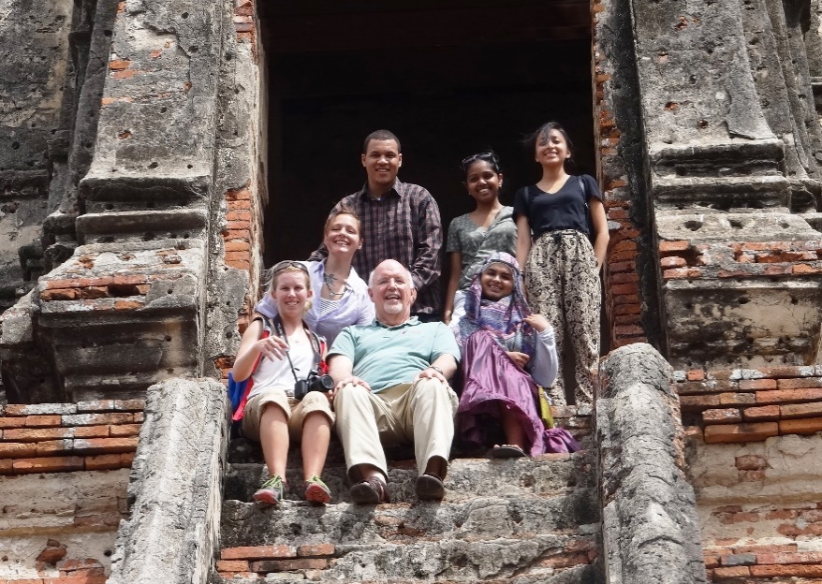

Course period: May 21, 2016 to June 4, 2016
Session prior to departure-a doodle poll to get the best time for all of the class.
Session after we return-a doddle poll to get the best time for the class.
Credits: Three (3) credits
Faculty Director: Mark Gregory Robson, PhD, MPH, DrPH robson@aesop.rutgers.edu

Course Objectives
This course is designed as part of a service learning abroad program. Students will be exposed to everyday life in Bangkok, Thailand’s capital and largest city. Bangkok has a population of nine million, it is a unique cultural and economic center for SE Asia. Students will be exposed to the rich Thai culture that is steeped in the Buddhist tradition for over 2500 years. For some general information about Thailand go to this link, the US CIA fact sheet on the Kingdom of Thailand:
https://www.cia.gov/library/publications/the-world-factbook/geos/th.html

The service learning component will be coordinated with Cross Cultural Solutions (CCS). Their link is here: http://www.crossculturalsolutions.org/destinations/thailand/bangkok

In this course students will:
- Learn about Thai culture, government, educational system and the health care system.
- Students will participate in a number of cultural and enrichment activities.
- Students will be actively engaged four (4) days per week in a service learning program from 08.00 to 14.00 (Monday to Thursday).
- Students will meet and interact with students from Thailand’s oldest and most prestigious higher education institution, Chulalongkorn University.
- Students will visit a rural community where Dr. Robson is currently do health based research on pesticide use and the effects on farmers and farm families.
- Students will have a have one of the most rewarding and interesting cultural and learning experiences to date in their Rutgers career.

Course Requirements and Grading

Students will receive three (3) credits for their participation in this program and additional credit for an additional independent study option is available. Please discuss with Dr. Robson.

Students will be required to do a series of readings prior to the trip and during the time in Thailand, these will be discussed on the trip and participation will count towards the grade (30%). Students will keep a journal for the two week period in Bangkok and that will be turned in as a part (40%) of the grade. After the return to the US students participate in a one day symposium to evaluate the project and make an individual presentation on their Thai experience (30% of the grade).

Journal of the Service Learning Experience

Beginning with your arrival in Bangkok you will start keeping a journal. This diary is the place where you record your observations and experiences of your time in Thailand, as well as your personal reactions to what you are observing and experiencing in your daily lives and in your community service activities. Use the journal to reflect on your experiences and relate them to what you are reading about and discussing in the course. During your first week, be sure to consider the following questions: What are your reactions to your new surroundings in Thailand? What things strike you as unfamiliar and unexpected? What things seem familiar? How are you adjusting to your living situation, working with a new group of students, and navigating a strange city? How does what you’ve seen so far match or conflict with your prior expectations?

Attendance and Participation

Dr. Robson and Cross Cultural Solutions have a detailed outline students are required to participate in all the mandatory session. There will also be free time available for the students where they can explore and engage in their own activities.

Service Activity

Dr. Robson and CCS have agreed that the service learning component will be about 50 percent of the time in Bangkok and will include working in educational setting for children and in a health care delivery setting. You will be instructed about this site and the duties when you arrive and there will be organized transport to and from the location each day. Service learning project will be Monday to Thursday from 08.00 to 14.00 with a one hour lunch break.

Disciplinary policy

There is a zero tolerance policy for student misbehavior while on this trip. Thailand is a much more socially conservative society than the United States and you should conduct yourselves accordingly. I do not regularly supervise participants’ behavior outside of class activities; any reports of students getting into trouble with host families or local authorities may result in disciplinary action, possibly including the student returning home immediately and receiving a failing grade in the class. Students should know and abide by the Rutgers University academic honesty policy in preparing course work. Students are required to sign a Behavior Policy form.
Faculty Profile
Mark Robson is Distinguished Professor and Chair of Plant Biology and Pathology and Professor of Environmental and Occupational Health at Rutgers. Dr. Robson has worked extensively in SE Asia for twenty years, particularly in Thailand. His work focuses on the health of rural people and agricultural production practices. Chulalongkorn University, Thailand’s oldest and most prestigious university conferred an honorary degree on Dr. Robson in 2010 for his many contributions to the university and the Kingdom in health science and risk assessment. robson@aesop.rutgers.edu a look at his research work in SE Asia can be found at http://thaiitreoh.rutgers.edu/

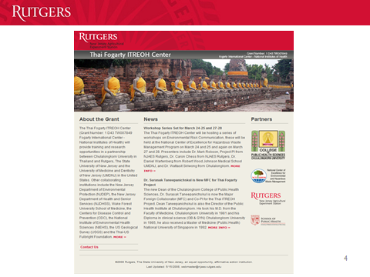
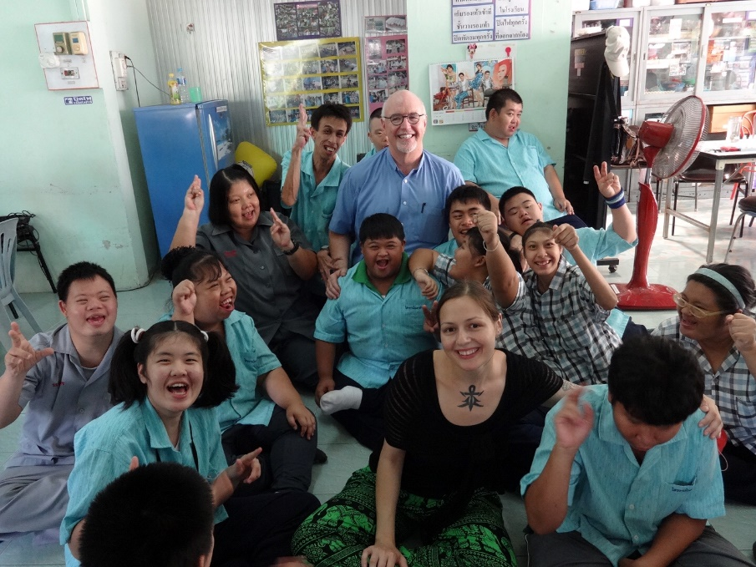
Summer 2016: Rutgers- Global Health and Service Learning in Thailand
Professor Mark Gregory Robson
Through this design, the students will be able to identify health issues in the country and community while participating in hands-on impacts in the area of global health. CCS meets these goals through the cultural programming as well as the volunteer work assignment.
A general overview: presentation showcasing health issues in the country. This profile will contain information on health trends, access to healthcare and medication and general health challenges facing the population.
A provider perspective: visit to a hospital or clinic where they can receive a tour and presentation from a local medical professional. Through this activity they will be able to view hoe a local facility works first-hand, draw comparisons to healthcare and facilities in their home countries, and learn about the population cared for and health trends treated in the facility.
A patient perspective: the group will have the opportunity to meet an individual or patient advocate who is currently under treatment for cancer, heart disease or another persuasive issue. This session will focus on care they are receiving and challenges they have experienced – referrals, payments and other issues from a personal perspective. This session takes place in a treatment facility, home-base or a home visit.
The volunteer work assignment will further support students’ understanding of health through direct care which will include:
Improvement of physical and emotional health of the elderly population through mobilization, physical therapy, companionship, and nutrition.
Care for the health of children and infants and addressing malnutrition through health campaigns; nutrition and exercise, and hygiene, including the importance of brushing teeth and hand washing, sex education, etc.
Working to provide an improvement of care for those who have a disability through physical therapy, nutrition and mobilization, and emotional support to the beneficiaries and their families.

CULTURAL ACTIVITIES
WEEK 1 | Week 1 | WEEK 2
Monday (Visakabucha day) | 0800 am-1200 noon: Grand Palace, Emerald Buddha Temple, and Reclining Buddha Temple 7 pm: Candle Walk at the temple nearby | Monday | 4-5 pm: W/S on Teaching English to Thai Children (not mandatory)
Tuesday | 4-5 pm: Thai language | Tuesday | 4-5 pm: Thai language
Wednesday | 4-5 pm: Group Meeting Free evening | Wednesday | 4-5 pm: Reflection Meeting Free evening
Thursday | 4-6 pm: Traditional Thai Massage w/ Demonstration | Thursday | 4-6 pm: Muay Thai Demonstration at local training camp
Friday | 0900 am-3 pm: Visit Lam Lukka District Hospital | Friday | 0900 am-3 pm: Visit Golden Mount and Canal trip

